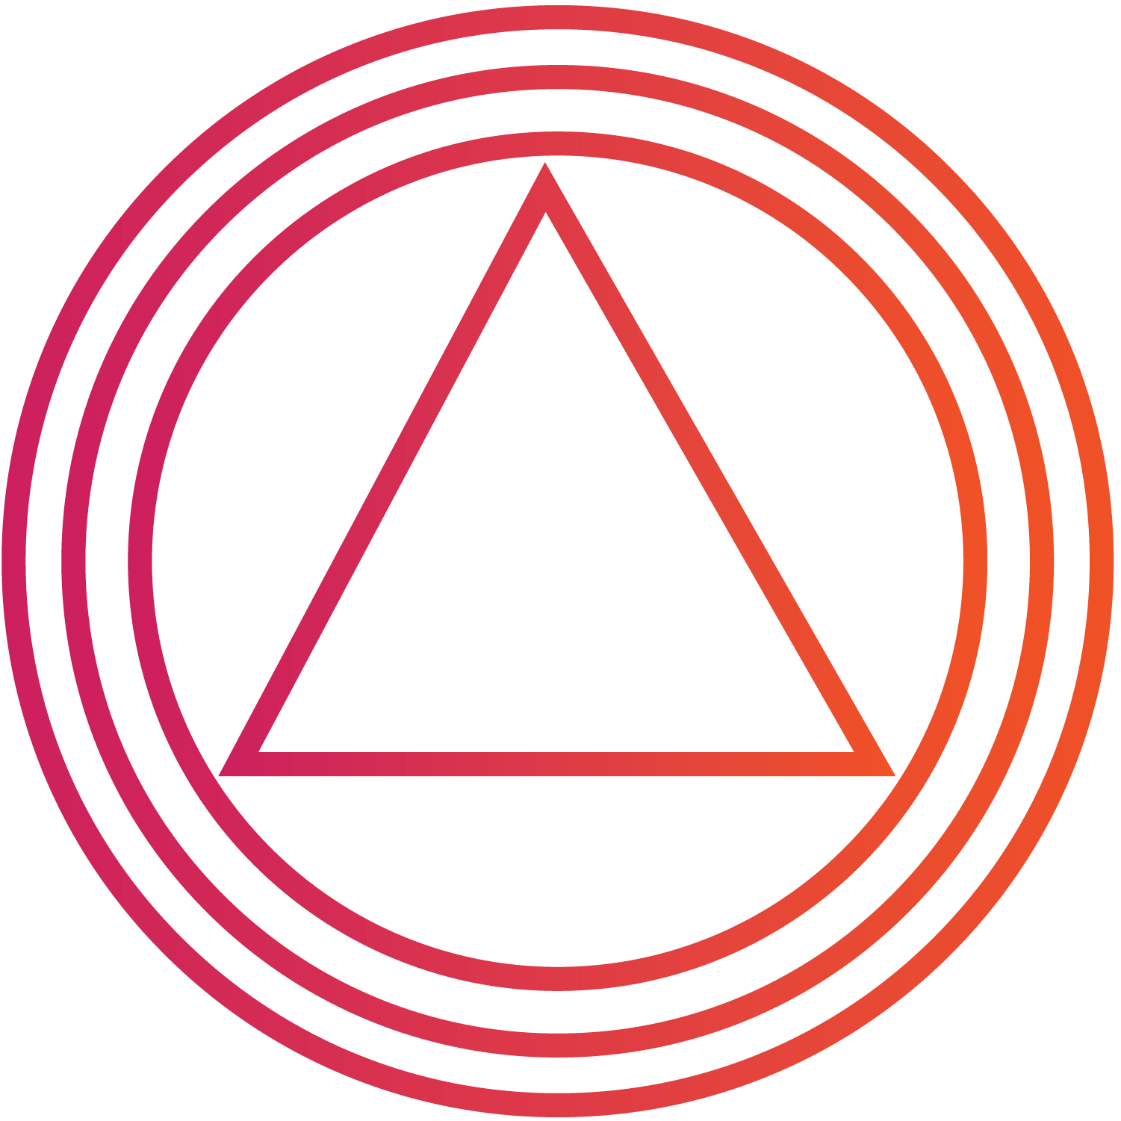
ALIGN TO YOUR DESIGN
Career, Life & Leadership
Exploration

with christine arylo
Congratulations on taking a step towards expansion, clarity and commitment to intentionally design the next cycle of your career, life, and leadership. I am a big believer in the power of taking a pause before we make significant decisions to give ourselves space to explore and tune into our deeper wisdom. Having support and guidance in the process is key to illuminating insight and wisdom we often can’t see or articulate on our own.

I’m honored to be part of your support & guidance team and look forward to learning more about where you are now, where you’ve been, and what you know about what’s calling you forward into the next. I’m also curious about what’s unknown and what questions you’ve been pondering … there is always gold in what’s still in the mystery!

We will be working together to help you gain more clarity and to expand your perspective about the path ahead in this way:
- You now have the Align to Your Design Exploration Guidebook, which I created to take you through a 5-step process to shine light on where you’ve been, where you are, and what you know about what is next. Before we meet, you create space to reflect and put what you are thinking, considering, feeling and sensing into words. You’ll send me your responses before we meet.
- We’ll convene for a 90-minute to 2-hour mentorship consultation session, using what you share from the Exploration Guidebook as the foundation to start from – we’ll dive into all of these areas, get to the roots, expand what you can see, and you’ll leave our session with specific insights, inquiries, focuses and actions to explore and put into practice.
- You will work with the focuses we craft for 40-days as an intentional co-creative practice –the insight and breakthroughs will emerge in your daily life.
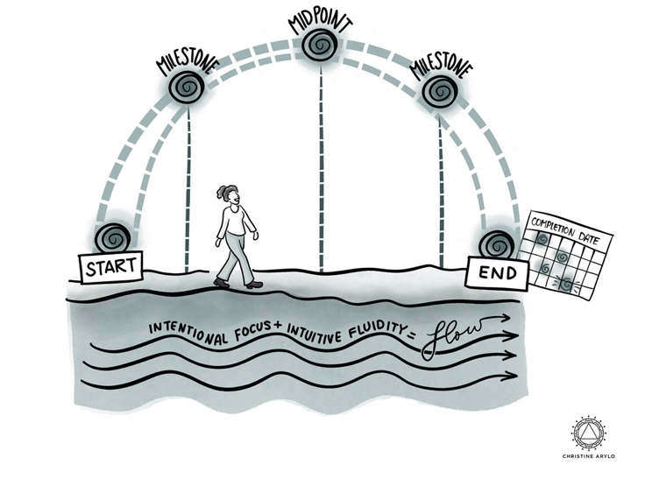
- We will reconvene for a reflection session after the 40 days / 6 weeks - to mine what you’ve learned and what insights have emerged, and use it all to set you up for the path forward.
This structure will create what is called an “intentional co-creative container” (see the glyph to the right for a visual.) We set a 40-day time span which creates the space to reveal insight and clarity.

Setting a defined time span with a start, midpoint, & end, with an intentional focus, opens up the intuitive space needed to contemplate, consider, experiment, receive input and guidance, tune into your internal guidance system, tap into what is real and right (and what’s not) and open up to possibility.

Why 40-days? 40 means enough. It takes 40 days to see and breakthrough patterns and unconscious imprints – which we all have. These imprints cause interference in our capacity to see clearly and expand beyond our current reality. Modern day scientists validated in takes between 28-30 days for your brain and mindset to see things differently. Yogic science and other wisdom traditions have taught for thousands of years that it takes 40-days for all parts – mental, physical, emotional, and spirit – to integrate and provide the kind of deeper, embodied insights and clarity we need if we truly want to shift our reality and align our choices with our design.
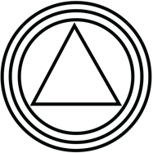

Prep for Our Consultation

Our consultation will be the most powerful and insightful if you do some contemplation and exploration prior to our session. I’ve put together this guidebook which takes you through a series of inquiries, divided into five parts, that will give us enough to work with, but not too much to overwhelm. These inquiries are based on the 20 years I’ve been doing this work, and I use them myself when I go through transitions.

- Reflect – Where You’ve Been
- Now – Where You Are
- Next – What You Know & What’s Unknown
- Meta – Bigger View of Your Purpose & Part
- More Specifics – Possibilities for the Path Ahead

You will send me your responses and thoughts at least 48 hours before our consultation, so keep that in mind as you embark on this exploration. You can send the responses to me in a word doc (if you type them in) or as a scanned PDF (if you handwrite out your responses). If you need support with this let us know.

My invitation is to make this a process that is insightful, valuable and enjoyable. DO create space to give thought and heart to these inquiries. Make this a priority because it matters to you. Get out of your head and have to’s. Leave your “I don’t know how to’s” and “That’s impossible’s” behind. This exploration process is for you, about what you truly desire and sense. For this process, what other people think or need isn’t relevant. Trust that if you are 100% honest with yourself, and what matters to you, everything will work itself out, in the flow.

This is not an exercise in having all of the answers. That’s part of why we are working together! In order to do things differently and see beyond limited perspectives, we need to tune into your full realm of intelligence. This starts with your instincts, intuition, heart knowing and higher consciousness. The intellect comes in later – its job is to map and sort after the other parts of you have revealed the wisdom.

Consider what you write a starting point to spark our consultation and open up what’s brewing within you in a way we can work with it.

Lastly, enjoy this process, remember it is for you. DON’T stress or make this a chore. DO engage and explore. Surprise yourself! A few ways to engage:
- Engage in a section at a time as a way to start your morning or end your evening.
- Get into an environment that feels inspiring so you can tune into the power of possibility, imagination and creativity.
- Let yourself “free flow write” for the first pass, no editing. Then go back and edit as a separate step.

I look forward to creating this space with and for you. I’ll be excited to receive your responses before our session.

If you have any questions before, you can reach me at Christine@ExpandingPossibility.org

ONE: REFLECT ON YOUR PATH
Where have you been?
Look back at this last cycle of your career. Think of the “cycle” in terms of a time period that feels like a full span with a start and an end. Like a full circle. You may still be in the cycle, you may be sensing like you are on the tail end of a cycle, or you may be in a new cycle already.

The intention of this reflection process is to illuminate the key points, experiences, events, roles and relationships that have influenced where you are now. This gives us a sense of all you have achieved on this part of your career and life path, and how the experiences influenced you. This will provide insight into what it’s time to complete & release, what to preserve & create momentum with, and what new things it’s time to create.

You can do this reflection in two ways. One, visually chart it out using the spiral visual on the next page or draw a spiral out on paper. Make a mark and a few words for each of the points, events, experiences in this past cycle. Then write your responses out to the inquiries below (also there is an additional blank page for extra space). Or two, just write out your responses without doing the charting on the spiral. Do what suits your design

Career Path
- Describe the key points of the career path you have been on in this current/past phase – name and describe what you received from each. What have been the:
  - Jobs and Roles Held

  - Milestones and Goal Met

  - Education and Training

- If you were to give this part of your career path a name or theme, what would it be?

Life Events
1. What 3-5 life events and experiences occurred during this cycle? How has each one shaped you as a human? And influenced your choices?

Impact You’ve Made
- What 3-5 ways have you made an impact through your work in the world in this cycle?

- How has your presence made a difference in your personal relationships and your professional relationships in this past cycle?

Relationships Made Impact on You

- What relationships have had the most impact on you in this last cycle?

- What did they teach, give or reflect to you?

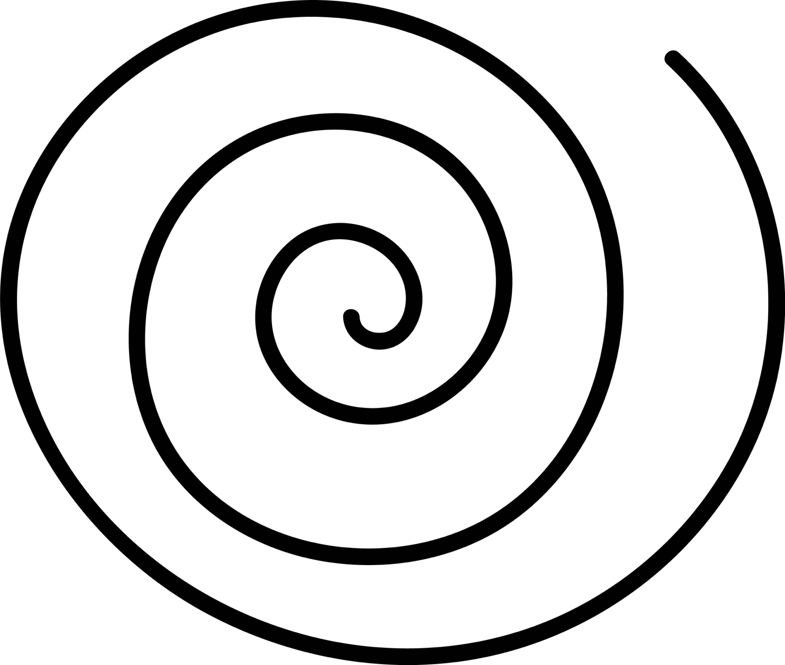

TWO: PRESENCE the PRESENT
Where are you Now?

Now it’s about giving language to the landscape you are standing in, your current reality by taking a look at your WHOLE LIFE. To do this, we use a different model I created for thinking about and seeing the “shape” of your life, so the reality you create next supports you to live a dynamic, diverse life in which all parts can thrive. Instead of trying to maintain work/life balance (which doesn’t work for the way our modern lives really work), or splitting yourself into two people, personal and professional, we use the metaphor of an orchestra. Your life has many parts, just as an orchestra has a variety instruments and sections. You stand in the center as the conductor, choreographer and dancer. The intention? Create HARMONY among all the parts.
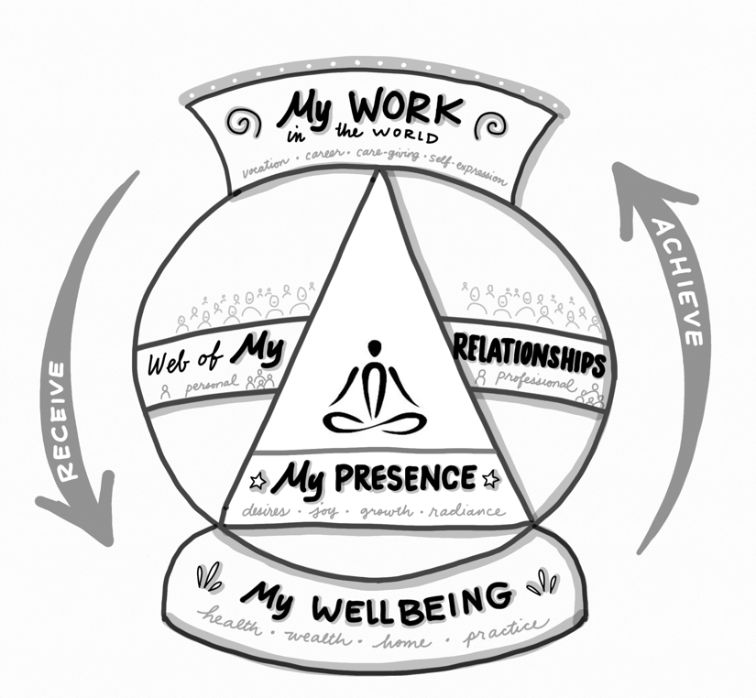
What you see to the right is the Achieve & Receive Model for Co-Creating a Whole Life. The model consists of the 4 realms, described below in more detail.

Part of shifting into an elevated reality is re-defining cultural constructs that keep us stuck in outdated paradigms that don’t work for how people and planet thrive and work best. The intention of this model is to expand and shift how you think about work, wellbeing, relationships, your impact, your desires, and what success looks and feels like for you, at this phase of your life.

Read the descriptions below about the 4 realms of a whole life. Refer to the glyph to see how it all works together. Then respond to the inquiries on the next page. This will give us a sense of what’s working, what’s not, what’s sustaining and supporting you, and what needs to shift.
- Work in the World: Vocation, Career, Care-Giving & Self-Expression. The projects, initiatives, desires and experiences in your: job/livelihood + parenting/care-giving + mentoring/volunteering + purpose/mission + career-path/self-expression (because all of these take work!)
- Web of Relationships: Personal, Professional, Individuals & Communities – Your personal relationships include your family, friends, partners, small groups and communities. Your professional relationships include your team, colleagues, mentors, councils, and communities.
- Foundation of Wellbeing: Health, Wealth, Home & Practice. Your health is your personal wellbeing + vitality… your wealth your financial flow + reserves… your home the space + place you live. Your practices are the consistent things you do daily/weekly for your BODY to stay healthy, MIND to stay clear, HEART to stay calm, centered & connected to yourself, and SPIRIT to keep your energy light, and your passion & sense of meaning strong.
- Presence - Personal Growth, Desires, Joy & Radiance – The being of you, how you show up, evolve from the inside out, and make a difference through your presence. The things that really matter to you, and that bring you joy.

Look at each of the 4 realms, respond to the inquiries below in terms of
what is true and real in your present reality.
- Work in the World: Career, Vocation, Care-Giving, Self-Expression
- Web of Relationships: Personal, Professional, Individual, Community
- Foundation of Wellbeing: Health, Wealth, Home, Practice
- Presence: Personal Growth, Desires, Joy & Radiance

1. What is IN Harmony? (feels supportive and aligned, while it may not be perfect or full desired state, it’s in flow)

2. What is In OUT of Harmony? (feels stressful, straining, like pressure, grinding, striving, off kilter, stagnant)

3. What do you desire to:

- SHIFT (create a different reality)

- STAY THE SAME (preserve)

- STOP (release)

4. What is no longer sustainable for you?

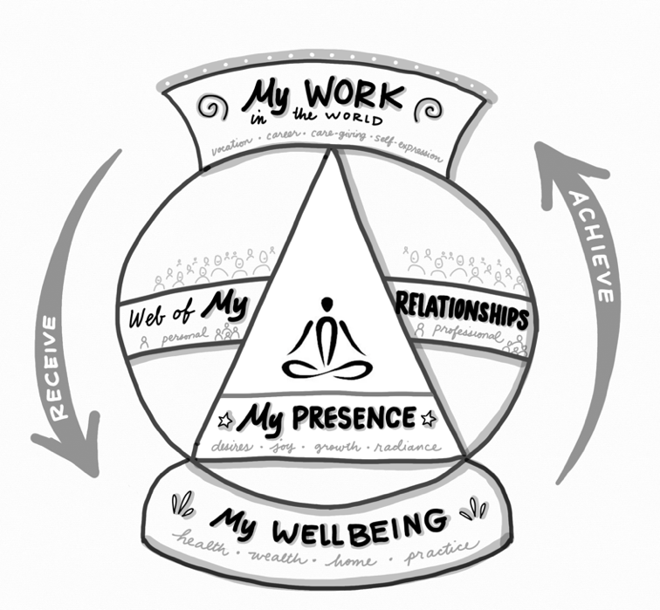
THREE: THE NEXT
What do You Know? What is Still Unknown?
We often know more about what is next than we realize we know. It’s just that it’s rambling around in our head, where we can’t see it or give language to it. In this step, standing where you are now, look forward into all 4 realms of your whole life, and write out both what you know and what you don’t know. Start with what you know, then go to what you don’t. Here’s some sparkers to help:
- I know I don’t desire... do desire…
- I know the next steps include…
- I know there is momentum & energy…
- I know this will support me… drain me....

My Work in the World – Vocation, Career, Care-Giving, Self-Expression
I KNOW | UNKNOWN

My Wellbeing Foundation – Health, Wealth, Home, Practice
I KNOW | UNKNOWN

My Web of Relationships – Personal
I KNOW | UNKNOWN

My Web of Relationships – Professional
I KNOW | UNKNOWN

My Presence - Desires, Joy, Growth, Radiance
I KNOW | UNKNOWN

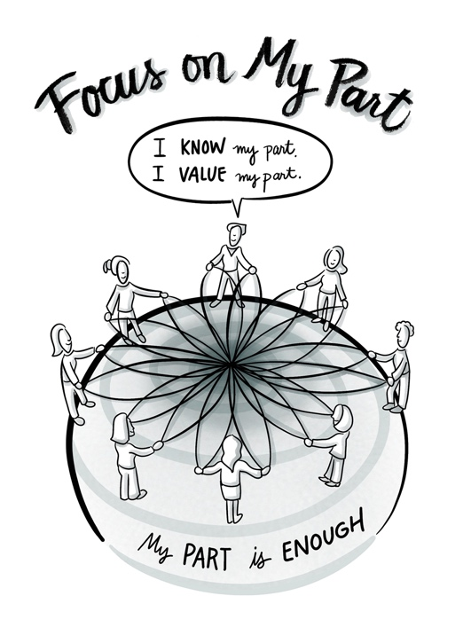
FOUR: THE META: Purpose, Part & Presence
Step Back to See the Bigger Why & What Your Part Is, and Is Not

Consider the integration of your gifts, experience, presence, and passion. Each of us have different parts to play through the work we do in the world and the way we show up in it. Remember the fuller definition of work, as well as the current inquiries you are exploring in relationship to the next focus & steps on your career path.

Look at the glyph to the right. This is what our world, organizations, teams, projects, families, and communities would look like if the culture operated from SYNERGY vs. silos, competition, sacrifice and hierarchy. This is naturally how we work, create, relate and live best as humans, however it’s not how most of us have experienced reality in the current culture, organizations, teams, and environments we live and swim in.

Most of us have had to adapt away from our natural inclinations and genius to survive and succeed in structures for work, wealth and wellbeing that value productivity over creativity, action over contemplation, and winning over wisdom. But now we stand at the brink of a new era, of which we are part of co-creating, through our choices and voices. As we each individually dare to do things differently, in ways that create harmony and synergy, collectively we will create healthy, long-lasting, vibrant workplaces, companies and communities that enable people to thrive. That’s pretty powerful! Personal transformation creates culture elevation.

Imagine a reality in which all people knew their part, valued their part and believed their part was enough. Burnout would be eradicated instantly. We’d create a much healthier society, where diversity and inclusion didn’t have to be an initiative, it’s just how we lived, naturally organized & valued things.

Now, here’s where our power to co-create culture comes in. We do this for ourselves first, and then impact the systems we swim in and the people we influence in them. This is part of our exploration together – bringing language, wisdom and choice to knowing, valuing and focusing on your part first. Then working with others professionally and personally to co-create synergistic realities.

Next are a series of 5 inquiries that we will touch on in our consultation and you will consider during your 40-day exploration. Consider these in the context of where you are now, and what you might want to create going forward in the next cycle of 3-5 years. These inquiries are ‘meta’ inquiries meaning they are meant to expand your mind into the realm of contemplation and imagination, so you can attune to what is and is not aligned for you in this next phase.
1. What I know about my natural gifts & super powers is…
These are the things you are innately good at, come easily and you can do/give with ease. Often we think everyone also has this ability, but really this is where our natural genius & design springs from.

2. I could best serve the whole in this next cycle by…
“The whole” could the world, or humanity, the ecosystems/professions you work in, the communities where you live, work, connect, and the family systems you participate in.

3. The change I wish to see in the world, or the reality I would feel good about giving my time and energy to in this next cycle includes…

4. In this next cycle of my career & life path, I know I do NOT want to give my energy and time to…

5. What I care about / am passionate about, but is not connected to how I create & sustain my financial livelihood includes…

FIVE: THE POSSIBILITIES
Here we want to get onto paper all those ideas rambling around inside where we can see them. Without editing, just free flow write, using the sentence starters in each of the 3 categories to create a list of all the possible ways you’ve been considering for what you could create, cause, call or focus on next.

Career, Creative Expressions, Work in the World, Roles Possibilities
- I could focus on now ….

- I could focus on next ….

- Ideas I have for projects or ways I could direct my energy & time in my work/career and in my overall life focus….

4. I would LOVE to …

Life-Phase & Life-Cycle Design

- I could choose to …

- I would LOVE to…

- If money wasn’t an issue I would totally …

Impact & Leadership

- I could choose to use my expertise, experience, presence by…

- I would LOVE to make a difference by…

- If money wasn’t an issue I would totally …

Lastly - Let’s Get to the What Matters Most to You: What matters most to me now and next in my…
Career Path & Vocation
Expression, roles, impact

Material Experience – Financial, Place/Home

My Wellbeing
Mind, body, heart, spirit

My Relationships - Personal

My Relationships - Professional

My Work Environment & Rhythm
My Lifestyle & Life Design

